## Problem 2 – Simple Site

Create a Web site (HTML5 + CSS3 + images) that looks and behaves like the screenshots below:

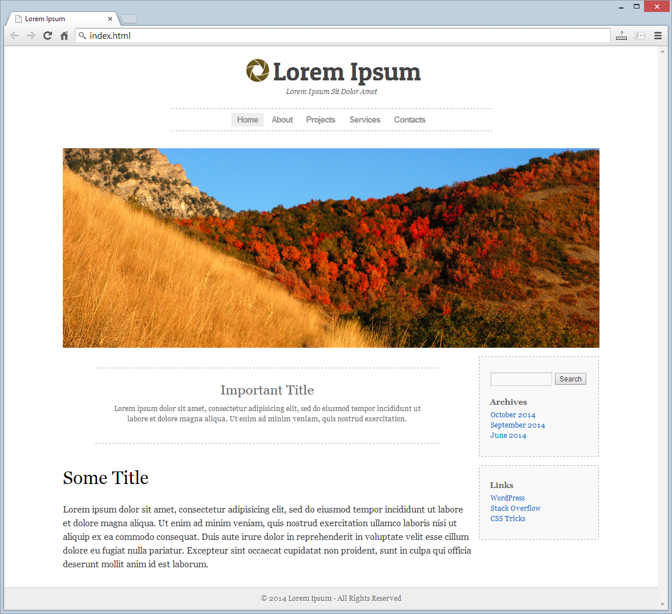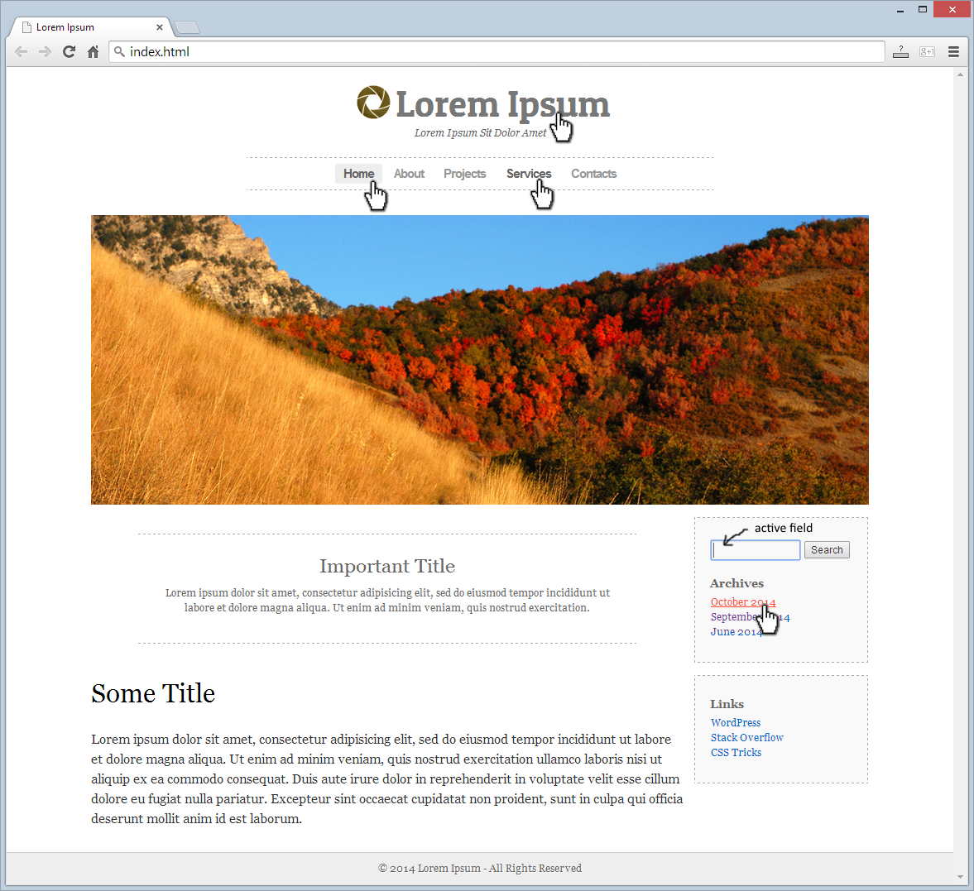

* The hand cursors in the screenshots show what happens when the mouse moves over certain elements.

### Input

You are given the above screenshots + the texts on the site + the site logo.

### Output

The output should be valid HTML5 + CSS3 + images that implement the above Web site.

### Constraints

* Fonts:
  + Site title: Patua One, 45px (<http://fonts.googleapis.com/css?family=Patua+One>).
  + Site subtitle: Georgia, italic, 12px.
  + Header navigation: Arial, bold, 15px.
  + Site content + site footer + sidebar: Georgia.
  + Search button: Arial.
* Site content: fixed width 940px.
* Header: width 564px.
* Footer: fluid width.
* The site should open correctly in Chrome 35.
* Responsive design is not required.
* Pixel-perfect implementation is not required.